Part 3 Technical Memo
A Longitudinal Study of County Health Insurance Coverage, 2010-2025
DATA 6700 Independent Study, Summer 2026
Seth Phillips

1. Study Overview
This memo summarizes the Weeks 9-11 work, the first two weeks of Part 3. Part 2 established a two-way fixed-effects model of the county-level uninsured rate and found that its headline result, the unemployment_rate sign reversal, held up under multiple robustness checks on the pooled sample. Part 3 asks a different kind of question: does that pooled result actually hold uniformly across counties, or is it concentrated in specific kinds of places? This memo covers four pieces of work addressing that question: trajectory clustering, a high-uninsured county profile, an income-tercile subgroup analysis, and a logistic regression connecting the clustering results back to Medicaid expansion status.
Weeks 9 through 11 are combined in this memo, since Week 9 trajectory clustering was started before the Part 3 guidelines arrived and was rebuilt to match them once received. Per the project guidelines, Part 3 also includes quantile regression and grouped hold-out-state cross-validation, which are not yet underway and are not covered here.
All code and outputs are available in the GitHub repository:
sphillips32/A-Longitudinal-Study-of-County-Health-Insurance-Coverage-2010-2025

2. Trajectory Clustering
3,125 of the 3,141 counties in the Part 2 modeling sample have a complete 2015-2025 uninsured rate trajectory (16 counties were excluded for at least one missing year). Each county's trajectory was standardized to its own mean and standard deviation before clustering, so the clustering groups counties by the shape of their trajectory rather than by their starting level.
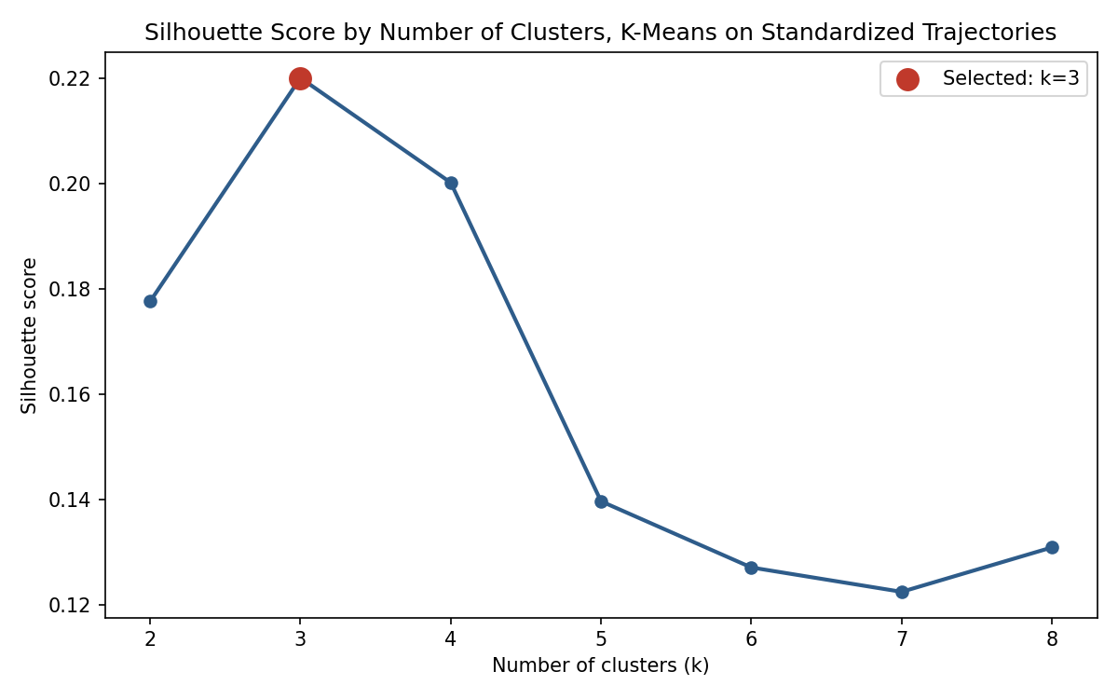
Figure 1. Silhouette score by number of clusters (k), K-means on standardized trajectories.
K=3 has the highest silhouette score (0.220) across k=2 through k=8, and the clustering is highly stable: refitting across 10 random seeds produced a mean pairwise Adjusted Rand Index of 0.998, with a minimum of 0.994. A second check confirmed the clusters reflect trajectory shape rather than starting level: clustering on the raw, unstandardized trajectories instead produces three groups that are essentially just level bands (low, mid, and high starting uninsured rates that decline in a similar overall shape), and agreement between the raw-based and standardized-based cluster assignments is only 0.093 by Adjusted Rand Index, close to no agreement at all.
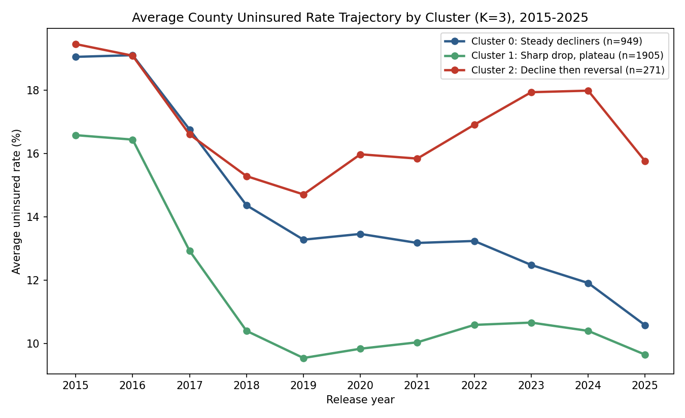
Figure 2. Average uninsured rate trajectory by cluster, 2015-2025.
Cluster | Counties | Non-Expansion Share
Cluster 0: Steady decliners | 949 | 20.3%
Cluster 1: Sharp drop, plateau | 1,905 | 21.2%
Cluster 2: Decline then reversal | 271 | 40.2%
Two of the three clusters describe variations on the same basic story: Cluster 1 (1,905 counties, the majority) drops sharply and plateaus by 2019; Cluster 0 (949 counties) starts higher and declines more gradually, reaching a similar endpoint by 2025. Cluster 2 (271 counties) is different: it declines through 2019 like the others, then reverses, climbing back to nearly its 2015 level by 2024 before dropping again in the final year. Cluster 2 also has roughly double the non-expansion state share of the other two clusters (40.2 percent versus 20-21 percent), a descriptive association tested directly in Section 5.

3. High-Uninsured County Profile
The top decile of counties by 2025 uninsured rate (314 counties, threshold 16.74 percent) was compared against the remaining 2,819 counties on all 13 Part 2 predictors.
Predictor | Difference (high-uninsured minus rest) | p-value
median_income | -$6,644 | < 0.001
pct_hispanic | +22.0 pts | < 0.001
pct_nh_white | -21.1 pts | < 0.001
some_college_rate | -10.1 pts | < 0.001
pct_rural | +9.4 pts | < 0.001
child_poverty_rate | +5.1 pts | < 0.001
single_parent_rate | +2.0 pts | 0.002
pct_under18 | +1.7 pts | < 0.001
pct_65plus | -1.3 pts | < 0.001
unemployment_rate | +0.4 pts | < 0.001
pct_black | -1.2 pts | 0.048
pct_aian | +1.3 pts | 0.014
pct_asian | -0.3 pts | 0.052
Twelve of the 13 predictors show a statistically significant difference (pct_asian is borderline at p = 0.052). The pattern is coherent: the highest-uninsured counties in 2025 are poorer, more rural, more Hispanic, and less college-educated than the rest of the sample. Most of these same predictors, child_poverty_rate, some_college_rate, and pct_rural, were also significant in the Week 6 fixed-effects model, a useful cross-check between the panel results and a simple current-year comparison. The large pct_hispanic gap (22 points) is notable since that predictor was not significant in the fixed-effects model; the Week 7 variation diagnostic found pct_hispanic has very little within-county movement (a variation ratio of 0.049), so this profile suggests it matters as a between-county characteristic rather than a within-county driver of change.

4. Income Tercile Subgroup Analysis
The Week 6 two-way fixed-effects model was refit separately within three income terciles (1,047 counties each, based on each county's own average income across 2015-2025), to test whether the pooled Week 6 findings hold uniformly.
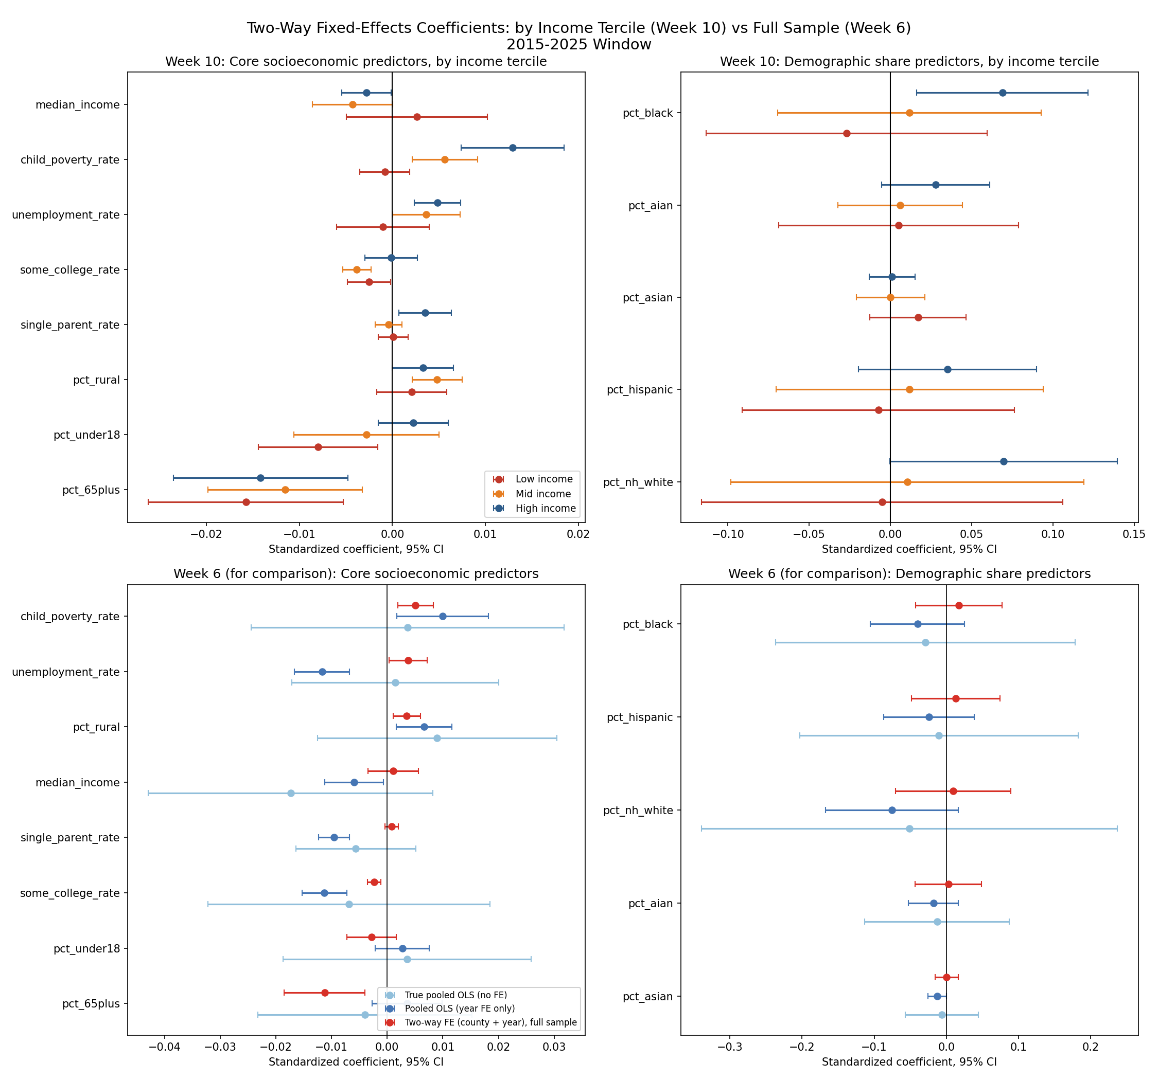
Figure 3. Two-way fixed-effects coefficients by income tercile (top row) compared against the Week 6 full-sample result (bottom row), 2015-2025 window.
The unemployment_rate reversal, the most important finding from Week 6, is not uniform across income groups. It is not significant in low-income counties (coefficient -0.0010, p = 0.681), matching the direction found in the original Part 1 pooled correlation rather than the Part 2 reversal. It becomes significant and positive in mid-income counties (0.0036, p = 0.048) and more strongly significant in high-income counties (0.0049, p < 0.001). The Week 6 pooled result was, in effect, averaging together a real relationship in wealthier counties with the absence of one in poorer counties.
pct_65plus is more stable: negative and significant in all three terciles. child_poverty_rate shows a similar income-dependent pattern to unemployment_rate, moving from non-significant in low-income counties to strongly significant in high-income counties (p < 0.001). The full 13-predictor comparison is in Appendix A.

5. Reversal-Cluster Logistic Regression
Section 2 found that Cluster 2 (decline then reversal) has roughly double the non-expansion state share of the other clusters. This section tests whether that association holds after controlling for county socioeconomic characteristics, using a logistic regression predicting cluster 2 membership from each county's 2015-2025 average predictor values plus its Medicaid expansion status.
An initial model with all 13 predictors plus expansion status showed severe multicollinearity in the demographic share predictors (variance inflation factors from 9 to 233, well above the conventional concern threshold of 10), the same instability documented in Part 1's ridge regression. A second model using only the 8 core socioeconomic predictors plus expansion status was fit as a check. The full model is in Appendix A.
Predictor | Coefficient | Odds Ratio | p-value
unemployment_rate | -0.841 | 0.432 | < 0.001
some_college_rate | -0.679 | 0.507 | < 0.001
child_poverty_rate | -0.603 | 0.547 | 0.004
non_expansion | 1.067 | 2.906 | < 0.001
pct_under18 | 0.500 | 1.649 | < 0.001
median_income | -0.357 | 0.700 | 0.039
single_parent_rate | -0.143 | 0.867 | 0.262
pct_rural | 0.087 | 1.091 | 0.360
pct_65plus | -0.015 | 0.985 | 0.906
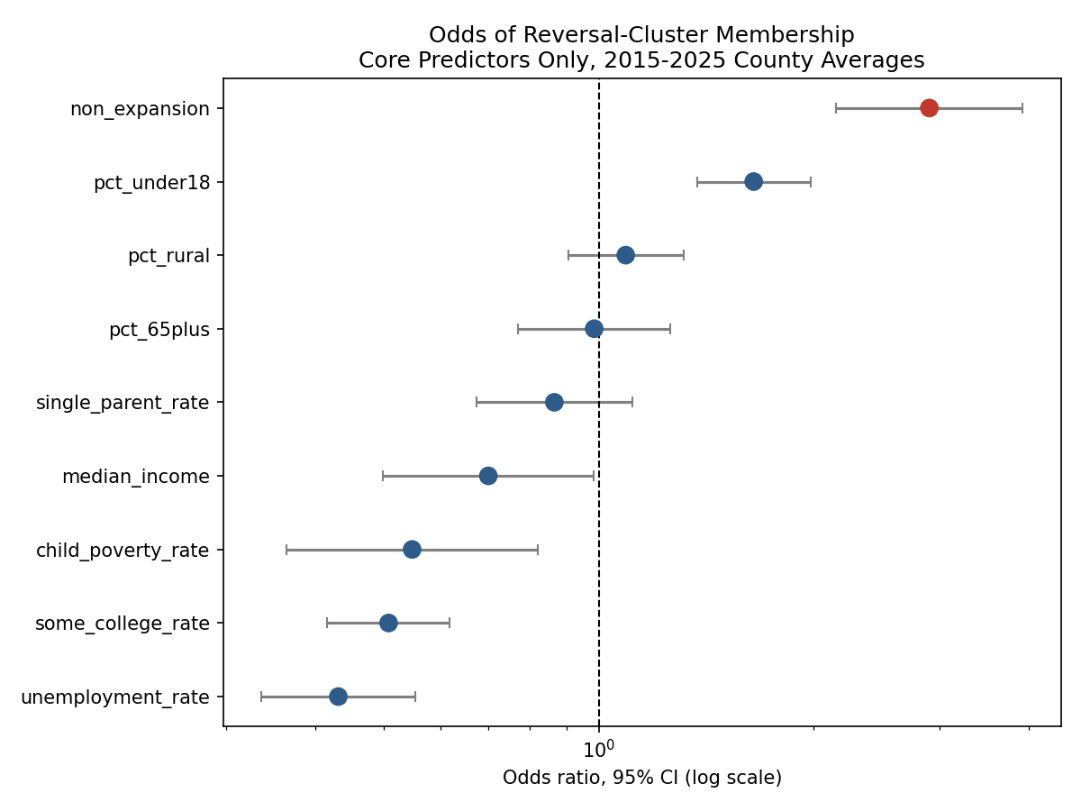
Figure 4. Odds ratios and 95% confidence intervals for reversal-cluster membership, core predictors only.
non_expansion is significant in both specifications and strengthens once the collinear demographic block is removed: coefficient 0.87 in the full model, 1.07 in the core-only model (both p < 0.001). The core model's odds ratio is 2.91 (95 percent CI: 2.15 to 3.93): a county in a non-expansion state has roughly three times the odds of belonging to the reversal cluster, holding the core socioeconomic predictors constant. This confirms the Section 2 association is not simply a byproduct of non-expansion counties also being poorer or more rural.
unemployment_rate, child_poverty_rate, and some_college_rate are also significant, all with negative coefficients, meaning counties with higher average unemployment and poverty, and lower average college attainment, are less likely to be in the reversal cluster. This describes which counties fall into which broad trajectory group based on their average characteristics, a different kind of relationship than the within-county year-to-year effects estimated in Section 4, and the two should not be read as contradicting each other.

6. Summary of Findings
Four analyses this period point in a consistent direction: the Week 6 pooled fixed-effects results describe an average relationship that does not hold uniformly across the sample. The unemployment_rate reversal is concentrated in mid- and high-income counties. The counties furthest from the national coverage trend in 2025 are a specific, describable type of place, poorer, more rural, more Hispanic, less educated, largely the same predictors already flagged as significant in Week 6. A subset of counties (Cluster 2) saw their coverage gains partially reverse after 2019, and that group is disproportionately made up of non-expansion states even after controlling for other characteristics.
Together these results shift the project's central question. Part 2 asked which predictors relate to the uninsured rate on average. Part 3 is answering a sharper version of that question: for which counties, and under what conditions, do those relationships hold. The remaining Part 3 work, quantile regression and grouped hold-out-state cross-validation, extends this same shift from an average answer to a more complete one, and is a natural next step given the heterogeneity already documented here.

Appendix A: Full Model Tables

A.1 Income Tercile Comparison, All 13 Predictors
Predictor | Low Coef. | Low p | Mid Coef. | Mid p | High Coef. | High p
median_income | 0.0026 | 0.497 | -0.0043 | 0.051 | -0.0028 | 0.040
child_poverty_rate | -0.0008 | 0.544 | 0.0056 | 0.0016 | 0.0129 | < 0.001
unemployment_rate | -0.0010 | 0.681 | 0.0036 | 0.048 | 0.0049 | < 0.001
some_college_rate | -0.0025 | 0.032 | -0.0038 | < 0.001 | -0.0002 | 0.917
single_parent_rate | 0.0001 | 0.930 | -0.0004 | 0.566 | 0.0035 | 0.014
pct_rural | 0.0021 | 0.278 | 0.0048 | < 0.001 | 0.0033 | 0.050
pct_under18 | -0.0080 | 0.015 | -0.0028 | 0.483 | 0.0022 | 0.241
pct_65plus | -0.0158 | 0.003 | -0.0115 | 0.007 | -0.0142 | 0.003
pct_black | -0.0270 | 0.540 | 0.0117 | 0.778 | 0.0690 | 0.010
pct_aian | 0.0050 | 0.894 | 0.0060 | 0.759 | 0.0279 | 0.101
pct_asian | 0.0169 | 0.263 | 0.0001 | 0.995 | 0.0010 | 0.891
pct_hispanic | -0.0074 | 0.862 | 0.0118 | 0.778 | 0.0351 | 0.210
pct_nh_white | -0.0051 | 0.928 | 0.0104 | 0.851 | 0.0697 | 0.051

A.2 Reversal-Cluster Logistic Regression, Full Model with VIF
All 13 predictors plus Medicaid expansion status. Demographic share predictors are included for completeness; their individual coefficients should not be trusted given VIFs from 9 to 233. See Section 5 for the cleaner core-only specification.
Predictor | Coefficient | p-value | VIF
median_income | -0.456 | 0.019 | 4.98
child_poverty_rate | -0.919 | < 0.001 | 7.89
unemployment_rate | -0.765 | < 0.001 | 1.77
some_college_rate | -0.513 | < 0.001 | 2.39
single_parent_rate | -0.141 | 0.349 | 5.04
pct_rural | 0.177 | 0.098 | 2.26
pct_under18 | 0.315 | 0.002 | 2.02
pct_65plus | -0.040 | 0.759 | 2.36
pct_black | -3.258 | < 0.001 | 120.26
pct_aian | -1.636 | < 0.001 | 34.48
pct_asian | -1.384 | < 0.001 | 9.19
pct_hispanic | -2.759 | < 0.001 | 102.14
pct_nh_white | -4.817 | < 0.001 | 233.21
non_expansion | 0.865 | < 0.001 | 1.14

